

# Team 24 – Sprint 1 Testing Document

Sakshi Choudhary, Giorgi Khmaladze, Nick Litman, Mihir Somani, Conley Utz

# User Story #13

**Test 1: Testing that user cannot use inappropriate words/phrase as a username.**

Purpose: To meet the acceptance criteria, user should not be able to register to MyUniMarket with an inappropriate username

Steps:

1. The user uses an inappropriate word as username to sign up. (No user is created)

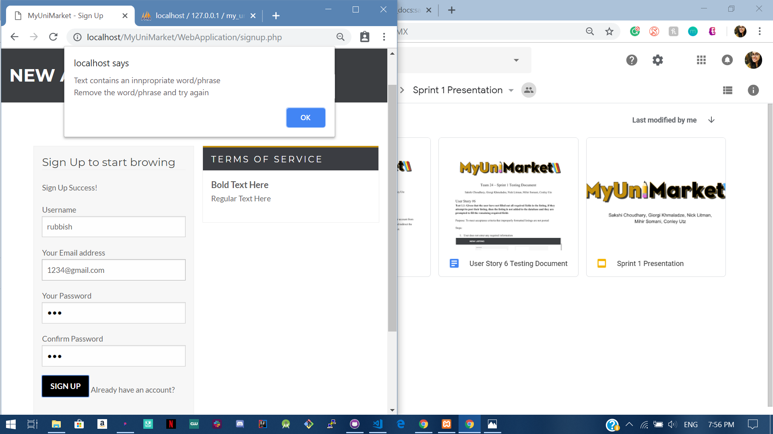

1. The user uses an appropriate word as username to sign up. (User is created)

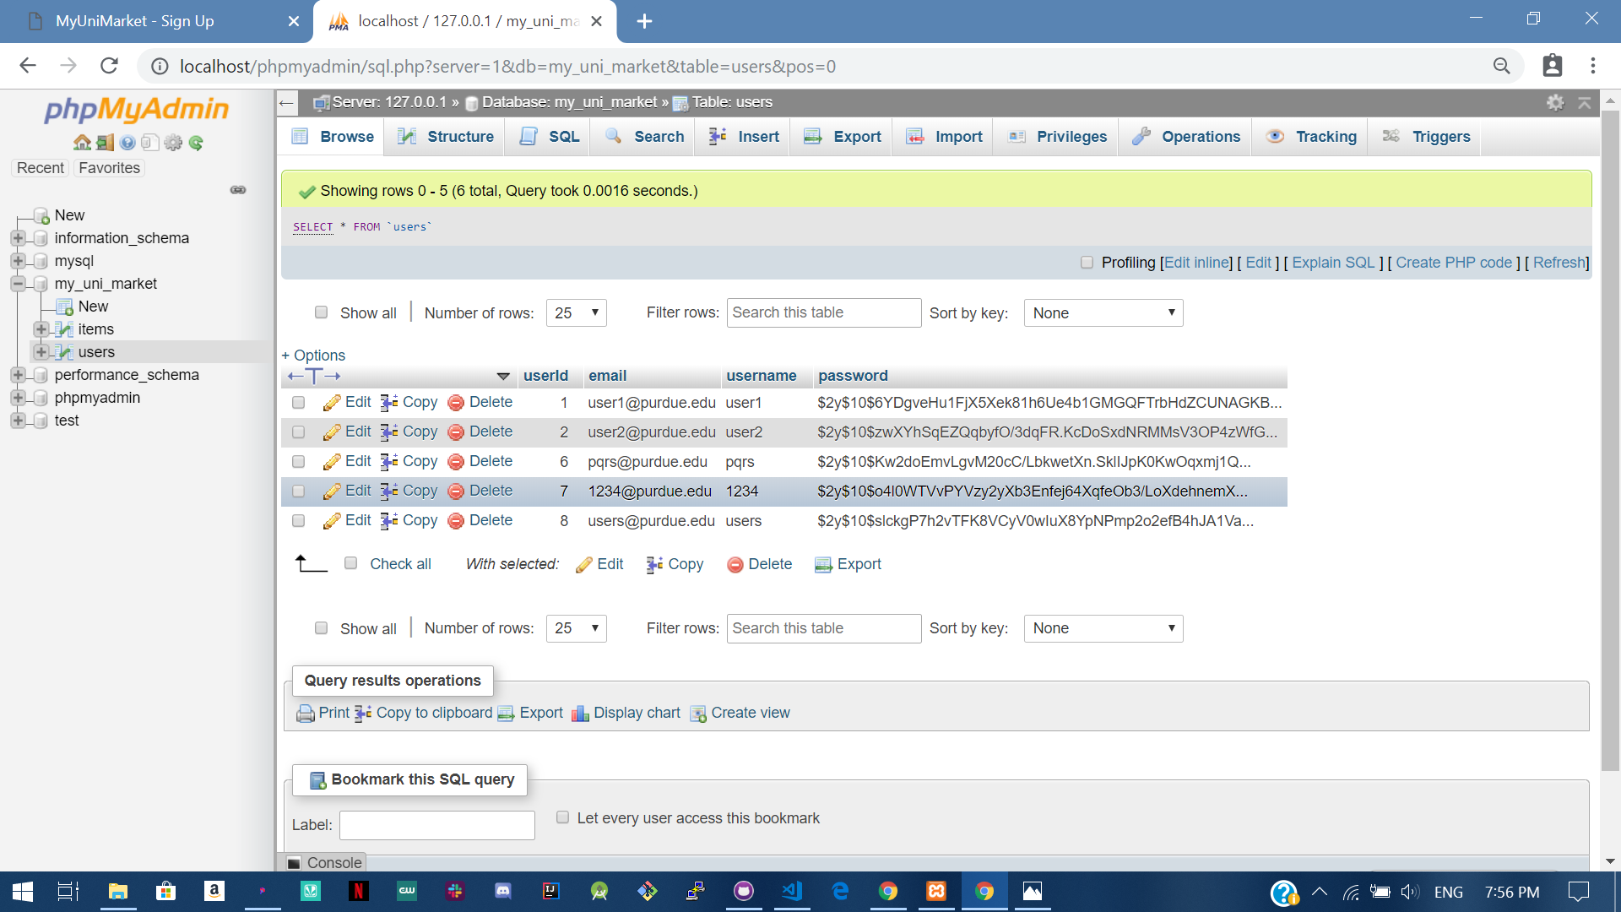

Expected Result: User cannot sign up if they use an inappropriate as username.

Test Result: **PASSED**

**Test 2: Testing that user cannot use inappropriate words/phrases as item details.**

1. The user uses an inappropriate word as name of the item for sale. (No item is listed)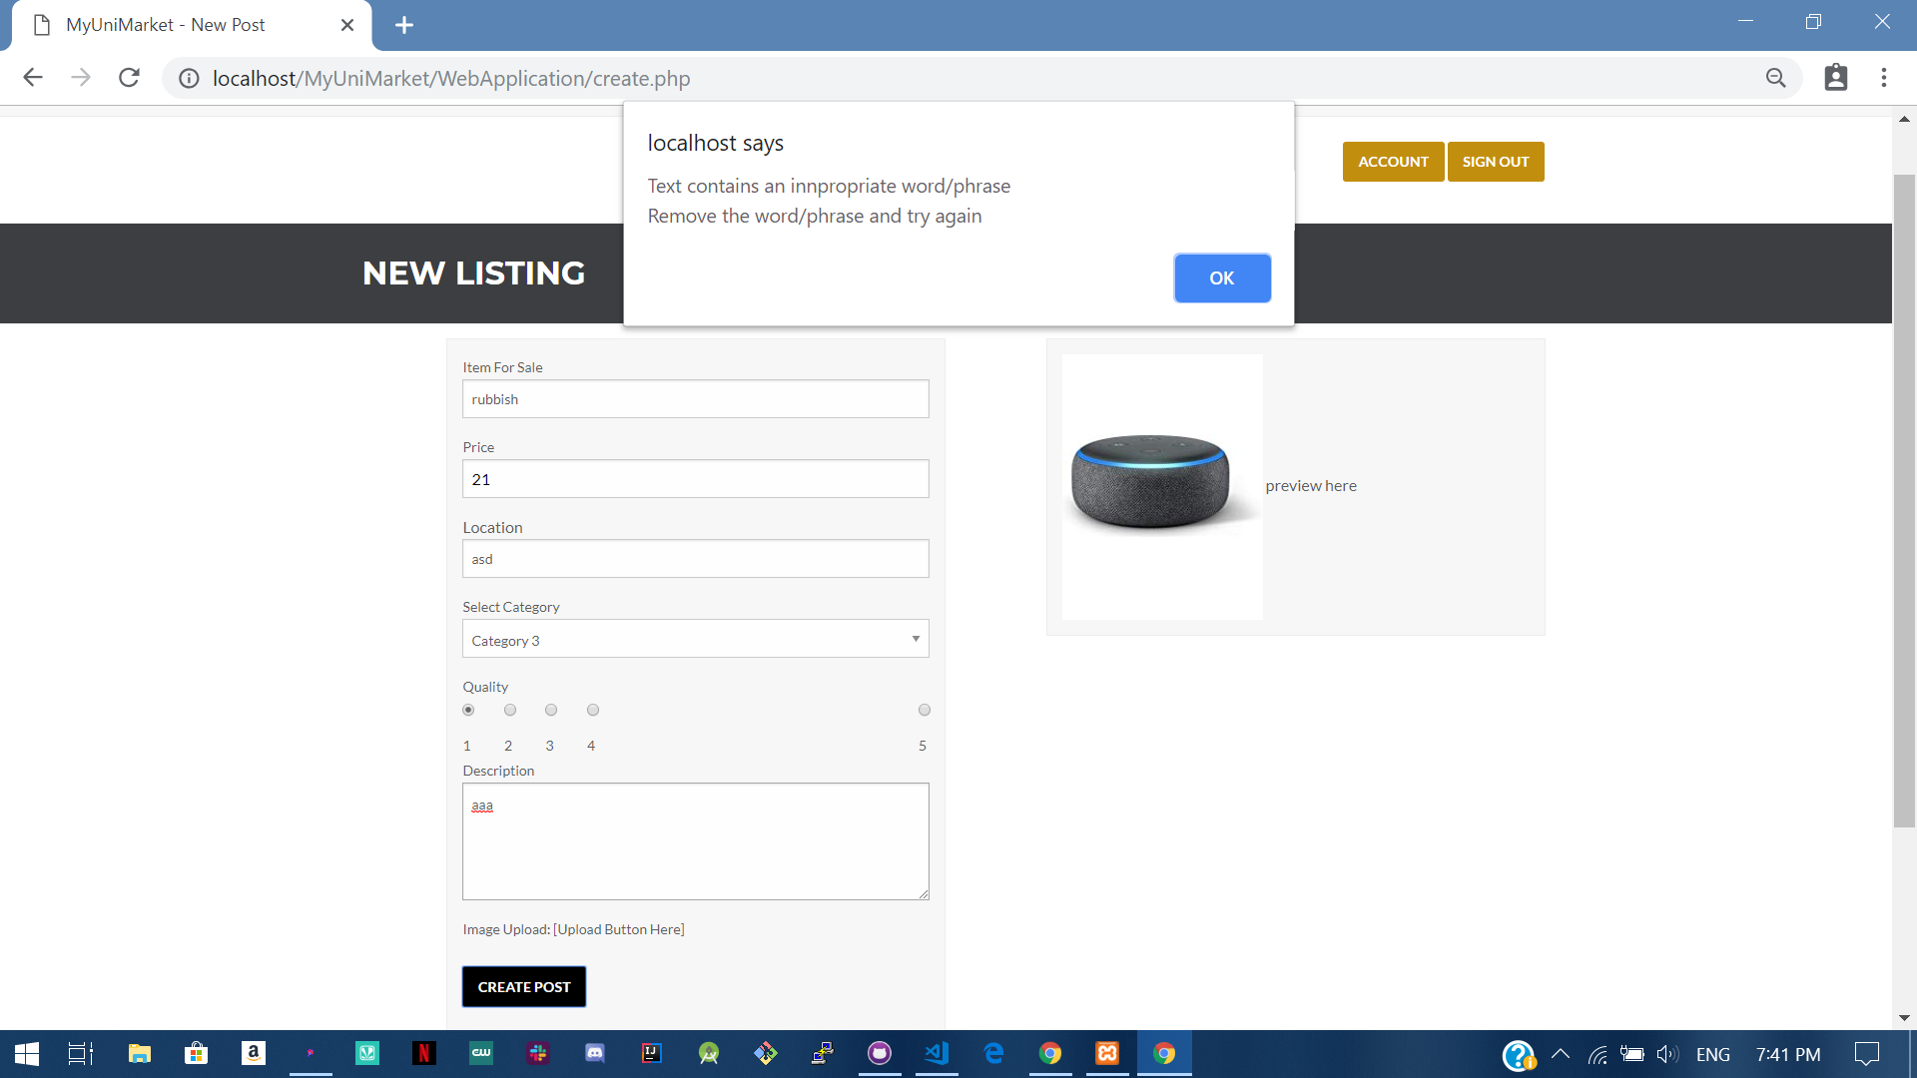
2. The user uses an inappropriate word as location for the item for sale. (No item is listed) 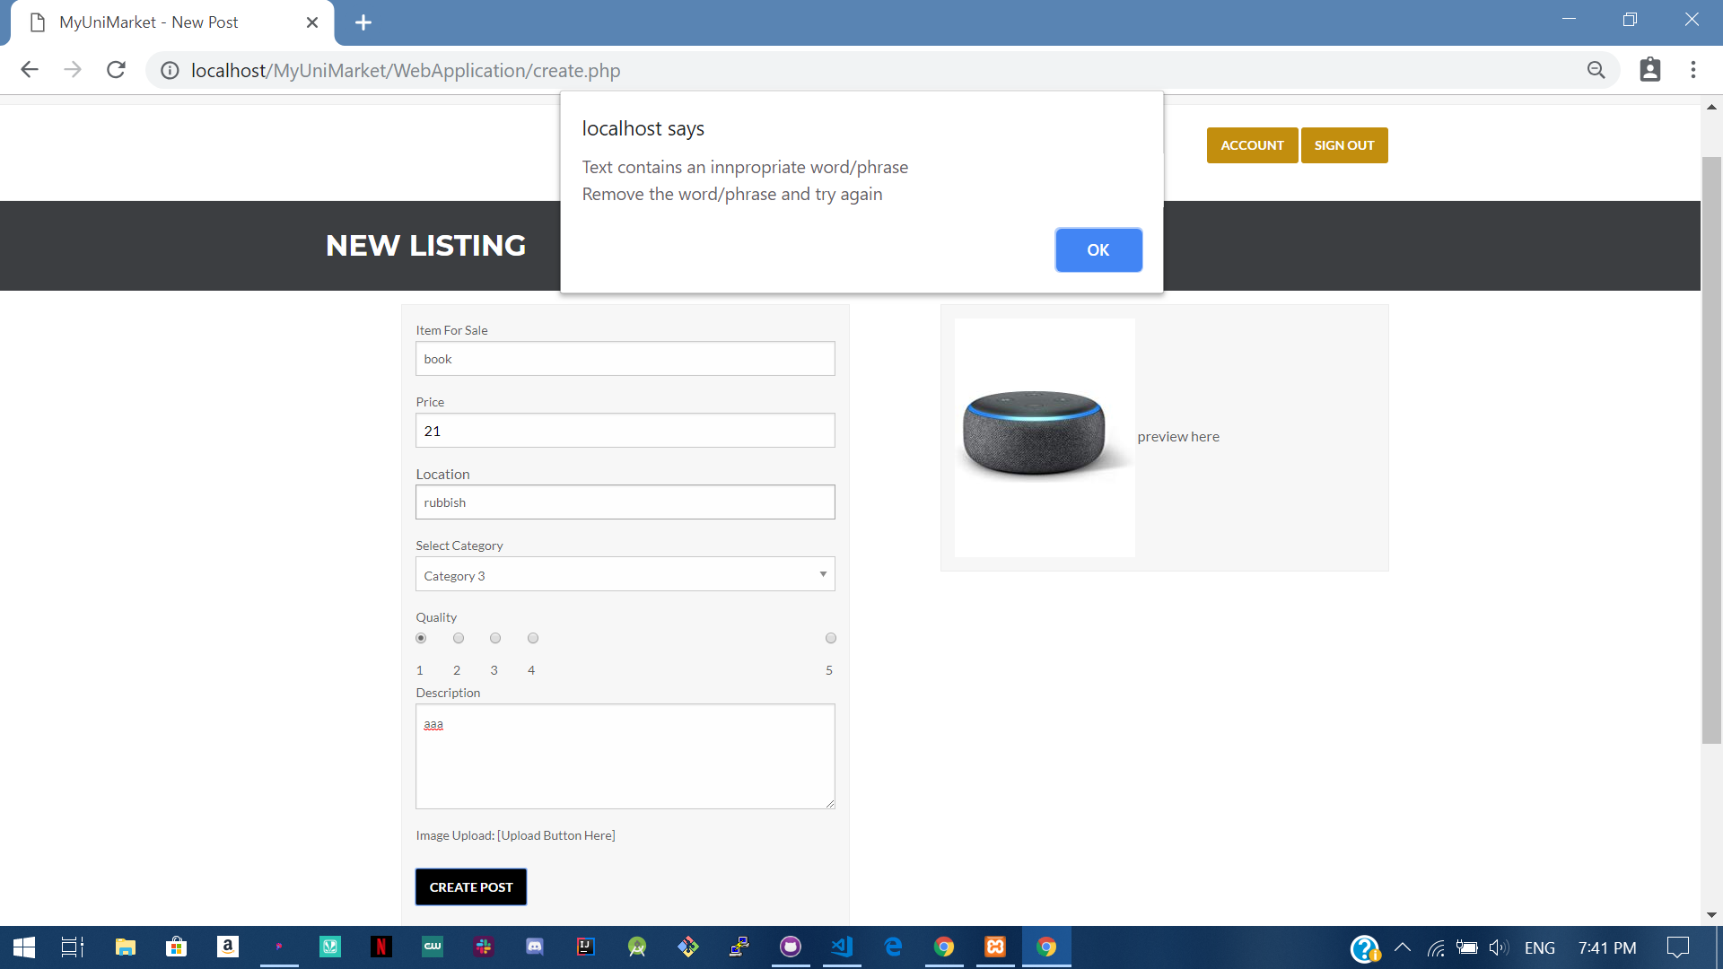
3. The user uses an inappropriate word as description for the item for sale. (No item is listed) 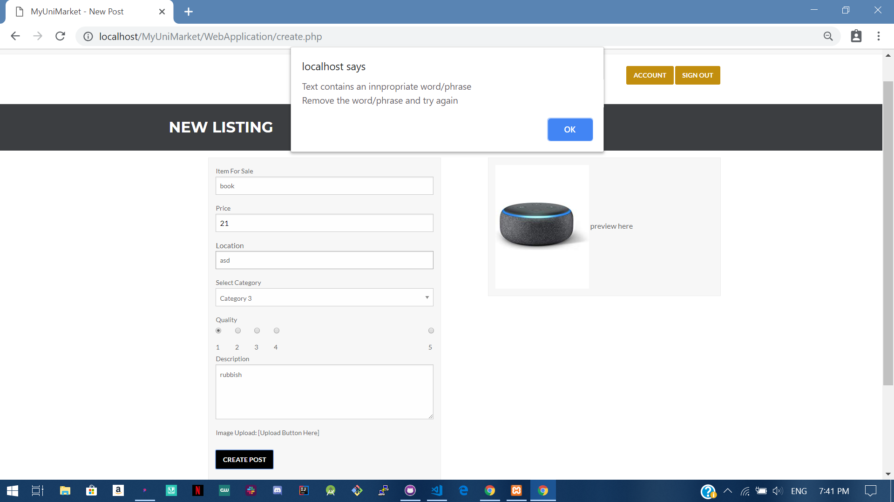

Expected Result: Item is not added to the database and user is asked to change the inappropriate word

Test Result: **PASSED**

**Test 3: Testing that if user does not use any inappropriate words/phrases the item is listed.**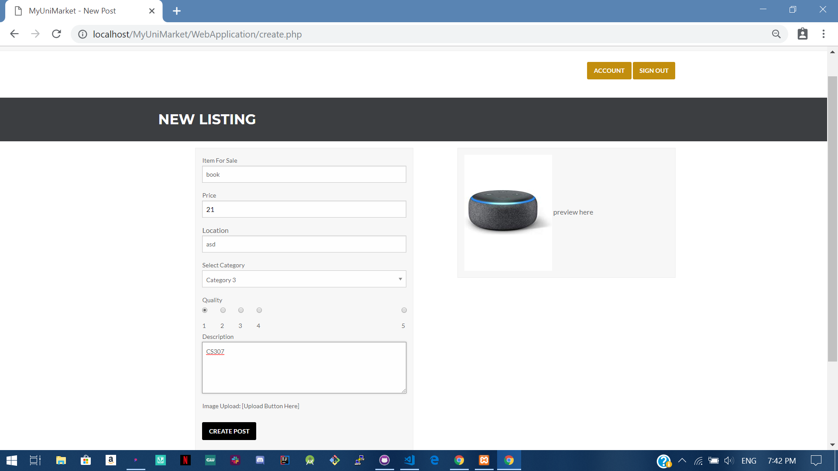

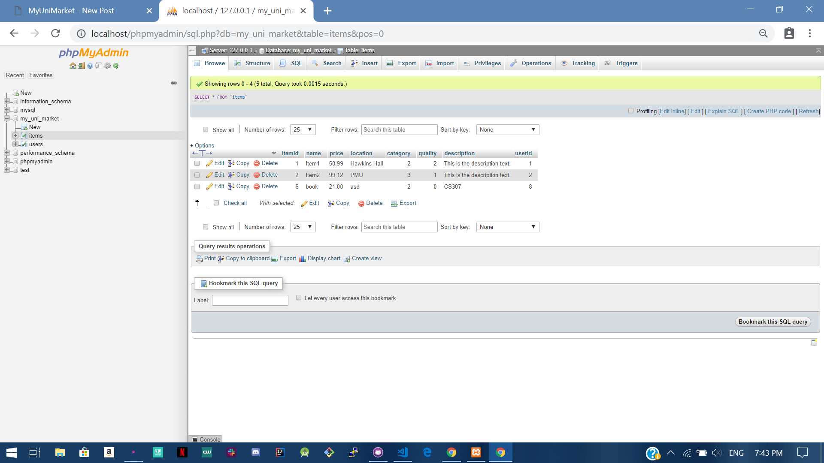

Expected Result: Item is added to the database

Test Result: **PASSED**